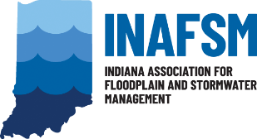
INAFSM Board of Directors Job Description
YOUNG PROFESSIONALS COMMITTEE CO-CHAIR

Duties as Stated in By-Laws: (None at this time.)

Responsibilities:
- Attend all board meetings.
- Maintain knowledge of the organization and personal commitment to its goals and objectives.
- Co-Lead Young Professionals Committee and establish groups or sub-committees as needed to carry out Board and Committee goals related to Floodplain, Stormwater, and MS4 program young professional.
- Develop committee work plan to reach identified target audiences.
- Work closely with Conference, Stormwater, and Floodplain Committee Chairs to assist with committee goals and needs.
- Responsible for young professional events.
- Prepares and submits written report to Board members prior to each Board meeting.
- Carry out special assignments as requested by the board chair.
- Keeps job description and all Young Professionals Committee Co-Chair position documents up to date.
- Maintain outreach among different professional associations/networks to recruit larger numbers of professionals that fall within the preferred age range.
- Develop and provide design suggestions for Young Professionals Committee webpage on INAFSM’s main website and maintain up-to-date event information/photos to keep participants informed.

