 | 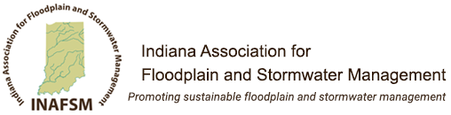 |  |  |  |  | FACT SHEET  Management of Dumpsters & Trash  May 2018  Revised: July 2018
 | Prepared by the INAFSM Stormwater Committee – Pollution Prevention and Good Housekeeping Group
 | Dumpster & Trash Management is Important:
 | Reduce Stormwater Pollution & Protect Local Waterways!  Your business is important to our community and, like other community partners, you need to properly dispose of business waste products. Do your part to prevent contamination and by-products from polluting streams, lakes, and groundwater. A few simple practices keep trash, sediment, chemicals, soaps and waste water out of storm drains and waterways.  What type of dumpsters does this apply to? |  |  |  |  |  |  |  | 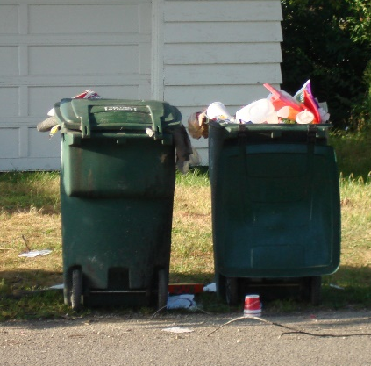  Loose trash becomes litter. BAG TRASH before disposal.
 | - Residential  - Commercial properties  - Businesses |  | - Apartment complexes  - Restaurants  - Industrial facilities
Steps to Maintain Residential Trash
Our community wouldn’t be what it is without our residents. Please be a good neighbor and keep trash in a container and out of our local waterways.
- Use trash bags instead of placing loose trash in the can.
- Keep trash can lids closed when not in use to keep rain and animals out.
- Secure lids to prevent wildlife and wind damage.
- Arrange pickup of large items with disposal company.
- Do not place hazardous chemicals in the trash. Instead dispose of them at a household hazardous waste drop off location. Explosion of these containers can cause injuries.
 | Steps to Maintain Property Dumpsters  Always keep dumpster lids CLOSED when not in use.  Fact is, if a property’s trash or recycling enclosure is a mess, along with the area it resides in, commercial and apartment tenants are less likely to make an effort to get the waste into the proper area! Do you want to attract customers or turn them away?  - Require tenants to use trash bags instead of placing loose trash in the dumpster.  - Secure lids when not in use to keep rain and animals out and prevent wind damage.  - Place dumpsters on concrete, never on grass or mulch and away from storm drains, ditches or conveyance channels.  - Do not place liquids or hazardous chemicals in the dumpster. Explosion of these containers can cause injuries.  - Use a broom for clean-up around the dumpster; NEVER hose down a dumpster or the pavement around it.  - Replace the dumpster when it is rusted, has holes or broken lids – contact your disposal company.  - Inspect dumpster frequently to ensure drain is closed. |  |  |  |  |  |  | LOOK AT THIS Example of a good dumpster – closed lids, no loose trash, in good condition & not leaking!
 | Restaurants & Food Waste
 | 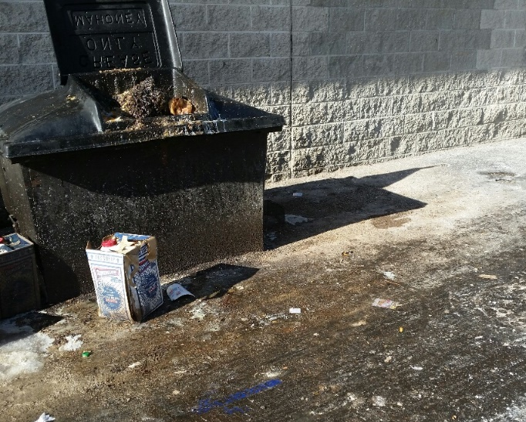  REMEMBER: You are not allowed to dispose of grease and oils down the sanitary sewer per local ordinance. |  |  | Steps to Maintain Restaurant Dumpsters  We all like to eat out…until you see this! Restaurants are required to prevent pollutants from entering the storm system just like any business.  - Install a grease trap or interceptor per local ordinance or community Fats, Oils & Grease (FOG) Program.  - Keep dumpster areas clean to not attract pests and wildlife.  - Keep trash and grease dumpster lids closed.  - Place dumpster on concrete and not grass or mulch.  - NEVER put oil or grease directly into a trash dumpster. Contact a grease hauler for a grease container and proper disposal.  - Prevent grease from dripping or overflowing when transferring to a grease dumpster.  - Use a broom for clean-up around the dumpster; NEVER hose down a dumpster or the pavement around it.  - Train staff on proper trash and grease disposal procedures.
 | Industrial Practices
 | Steps to Maintain Industrial Dumpsters  Remember that participating in a pollution prevention program can create a positive public image for your business.  - Locate industrial dumpsters on paved areas, away from storm drains and maintain a containment berm to prevent residuals from entering the storm system.  - Industrial dumpsters should be leak proof.  - Contact disposal company to replace damaged dumpsters.  - Keep dumpster areas clean by making an employee responsible for the area or making it a routine preventive maintenance order.  - Keep scrap metal or industrial waste dumpsters closed or covered unless adding waste to prevent stormwater accumulating in the bottom and mixing with residual oils or chemicals.  - Remove accumulated oils, chemicals and/or stormwater from industrial dumpsters prior to shipping off-site to prevent residuals from leaking from the containers to the roads.  - Train staff to recognize spills from dumpsters and appropriate clean-up methods and disposal practices.  - Dispose of contaminated or stained stone properly. |  |  |  |  |  | 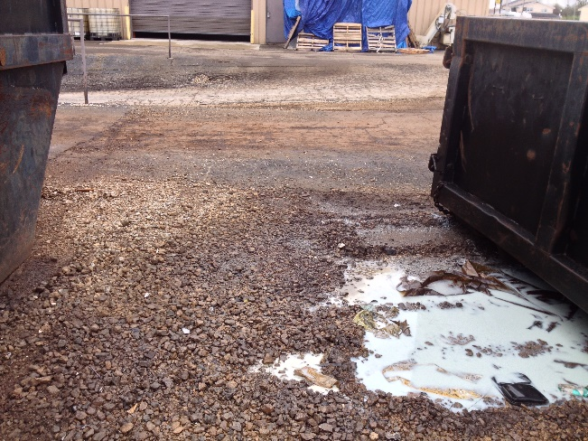  REMEMBER: Facilities with specific industrial activities exposed to stormwater may be required to obtain an NPDES Industrial Stormwater General Permit or Individual Permit from IDEM. Dumpsters must be managed as part of these permits.
If you have questions about this Fact Sheet, please contact the [Town/City] Stormwater Coordinator, [Name] at (xxx) xxx-xxxx or via email at [email address].
Information supplemented by: Universal Site Services and Stormwater Partners SW Washington.

